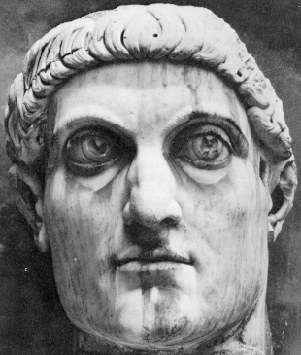

Constantine

the

Great

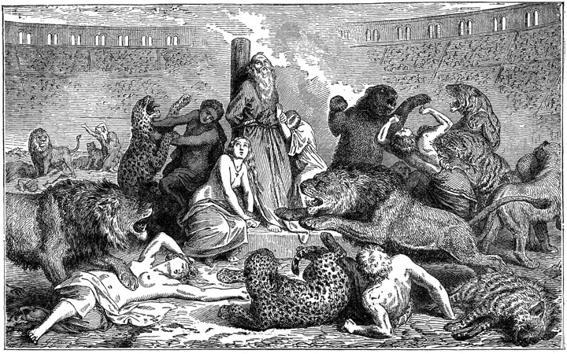

Chapter I
~~~

Ever since the time of Nero, Christians have been persecuted for their faith. They were flogged, beheaded, fed to lions, and even used as human torches. Things reached a pitch under Diocletian (r. 284 – 305 AD) who began
what was known as the Great Persecution. After consulting an oracle in late 302, he let loose upon the Church the fiercest of the persecutions in Roman history. The most horrible tortures were devised and the most barbarous punishments invented to the extent that even the barbarians were moved to give
shelter to the Christians. Decapitation or drowning was considered fortunate; in a large number of cases, death was delayed for as long as possible. After being tortured on the rack or having their eyes or tongue torn out, victims were allowed to recover before a second time through the works.
This same Diocletian had previously divided his empire into East and West and appointed his friend Maximian as co-Augustus in the West. Under the two senior emperors were appointed two junior emperors called Caesars. Each emperor thus ruled over a quarter of the empire; this system was to last for the next 30 years.

Roman Empire
West East

Augustus Augustus

Caesar Caesar

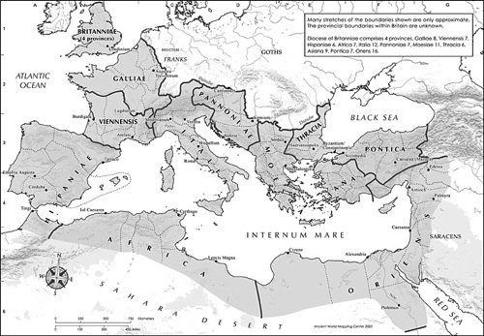

Chapter II
~~~

In 272 AD, a man was born who would change the course of human history. His name was Flavius Valerius Constantinus – or Constantine the Great. He was the son of Constantius, the Augustus of the West. Upon the death of Constantius in 306, Constantine was immediately proclaimed by his father’s army as the new Augustus. Over the next six years, he would consolidate his reign as overlord of Gaul, Spain, and Britain.
Meanwhile in Rome, Maxentius usurped the title of Augustus and would challenge Constantine for supremacy over the West. He was a cruel and bloodthirsty tyrant whose reign of terror soon had Rome clamoring for a savior.

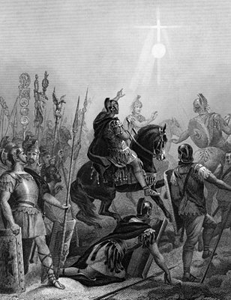
Chapter III
~~~

Early in the spring of 312, Constantine crossed the Cottian Alps with an army of 40,000. Marching at midday on Oct 27, he looked up and saw the symbol of a cross rising above the noonday sun. It bore the message – In Hoc Signo Vinces – or “In this sign, you will conquer.” Shocked and in awe, he immediately commanded his soldiers to paint the heavenly symbol on their shields and standards.
The following day, though outnumbered two to one by Maxentius’ forces, Constantine threw himself into the thick of battle, emboldened by his vision the previous day.
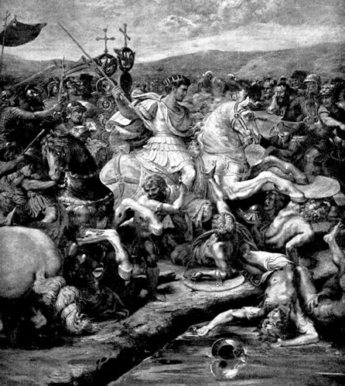
When the Battle of the Milvian Bridge was over, Maxentius lay drowned in the river Tiber as he attempted a retreat back into Rome. With his enemy vanquished, Constantine was now undisputed Augustus of the West co-equal to Licinius, Augustus of the East.
Constantine was convinced that the one true God – the God of the Christians – had given him the victory. His first act was to stop the persecution of Christians. The Edict of Milan in 313 returned all property confiscated from the Church and allowed Christians to worship freely.

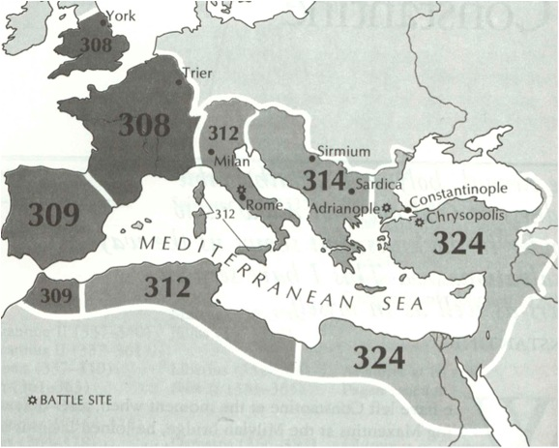
Constantine’s advances
Chapter IV
~~~

Peace was not to last, however, as Constantine and Licinius soon quarreled between themselves. As the two Emperors drifted further apart, Licinius became increasingly anti-Christian. This culminated in the great civil war of 324 between Constantine and Licinius which finally ended with Constantine as the sole emperor of the Roman Empire.
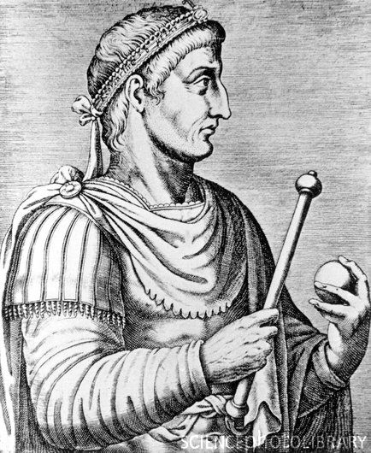

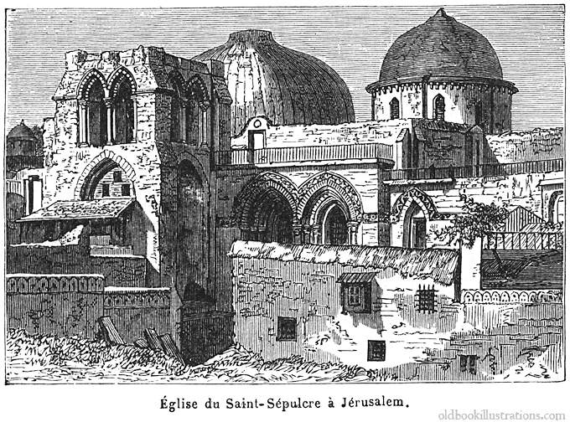

Chapter V
~~~

Constantine did more than stop the persecution of Christians. He dedicated numerous churches and basilicas to the glory of God such as the Church of the Holy Sepulcher in Jerusalem, the Church of the Holy Apostles, and Old St Peter’s Basilica in Rome.
Even more importantly, he faced down a heresy that threatened to tear apart the Church even as it rose from the ashes of persecution. Constantine convened a synod of 318 bishops to hammer out the fundamentals of Christianity. The Council of Nicaea which met in 325 was the first great Ecumenical Council.
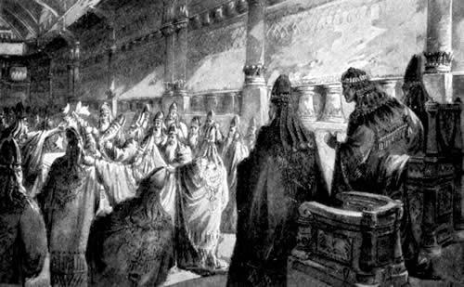
Finally, Constantine’s legacy will forever be marked by the city named after him – Constantinople. At the meeting point of Europe and Asia, this new Rome would endure for a thousand years after the fall of the ‘Eternal City.’ It would stand as the bulwark against Eastern invaders until the end of the Middle Ages.

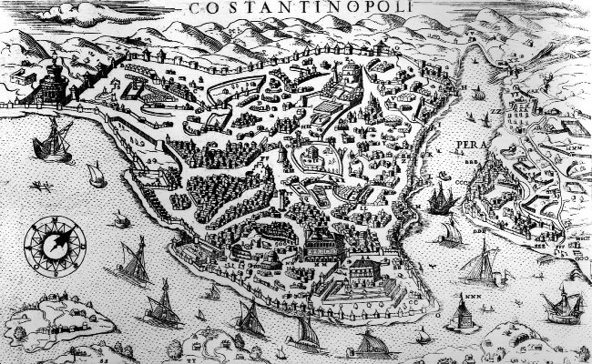

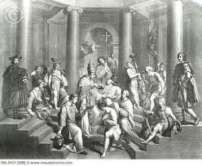

Chapter VI
~~~

In 337, Constantine sensed that the end was near. He travelled to the Church of Lucian in Drepanum and prayed. Falling upon his knees, he confessed his sins and was baptized. Shortly afterwards, after exclaiming: “Now I know in very truth that I am blessed; now I have confidence that I am a partaker of divine light,” the first Christian emperor breathed his last.
In less than a hundred years, Christianity would move from being a persecuted sect to becoming the official religion of the Roman Empire. Whether or not we believe in the Vision of Constantine, that in and of itself is a miracle.

History-Social Science Content Standards:-
6.7.7 Describe the circumstances that led to the spread of Christianity in Europe and other Roman territories

Sources:-
Eusebius. (336 – 339). Vita Constantini. (A. Cameron & S. Hall, Trans.). Oxford: Oxford University Press.

Firth, J. (1971). Constantine the Great: The Reorganization of the Empire and Triumph of the Church. North Stratford, NH: Ayer Company Publishers.

